Rayat Shikshan Sanstha’s

Dr.Patangrao Kadam Mahavidyalaya, Ramanandnagar (Burli)
“One Day Workshop on “Global leadership in Science and Innovation for Viksit Bharat”
Date – 28th Feb. 2025

Dr.Patangrao Kadam Mahavidyalaya, Ramanadnagar (Burli) ,department of Physics in collaboration with IQAC organized One Day Workshop on ‘One Day Workshop on “Global leadership in Science and Innovation for Viksit Bharat on 28th Feb 2025. The intention to organize this workshop is that India has the potential to lead globally in science and innovation, aligning with the vision of Viksit Bharat 2047. With strong government support, increased R&D investment, and a focus on cutting-edge technologies, India can emerge as a global powerhouse in science and technology. By addressing existing challenges and fostering a culture of innovation, India can shape the future of global science and innovation while ensuring sustainable and inclusive growth.
The introduction & welcome of this workshop was done by Mrs.Asha Madavi Head, Department of Geography. The Inauguration was done with auspicious hand by chief guest Mr.M.Y.Madvanna (Akhil Bhartiya Vidyan Parishad) and Hon.Prin. Dr. U. V. Patil president of this Function. Mr.M.Y.Madvanna has continued as a resource person and delivered the Guest lecture on the Supporting innovation-driven startups in cutting-edge fields like robotics, nanotechnology, and advanced materials. Dr.Gauri Patil gives introduction of the chief guest.Hon. Prin. Dr. U. V. Patil gave presidential address and she encourage the students for Research. The Vote of thanks was proposed by the Mrs. P. D. Jirage Head, Department of Mathematics There were 55 participants participated in this workshop.
Outcomes
- Students get awareness about future of global science and innovation while ensuring sustainable and inclusive growth.
- Students get ideas about innovation and invention
Beneficiries
Students-48
Faculty-07

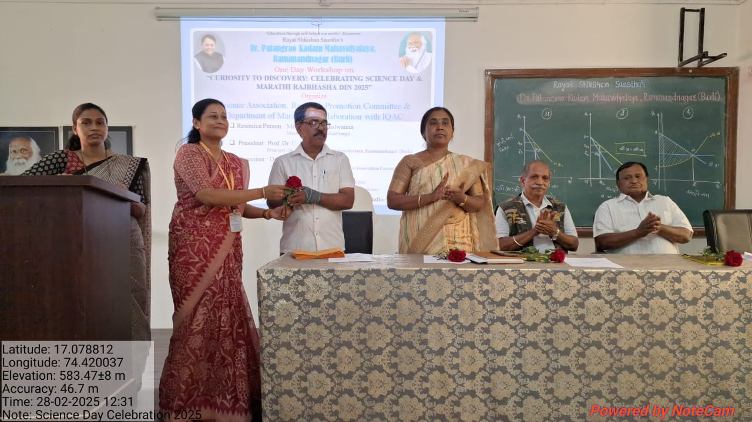 | 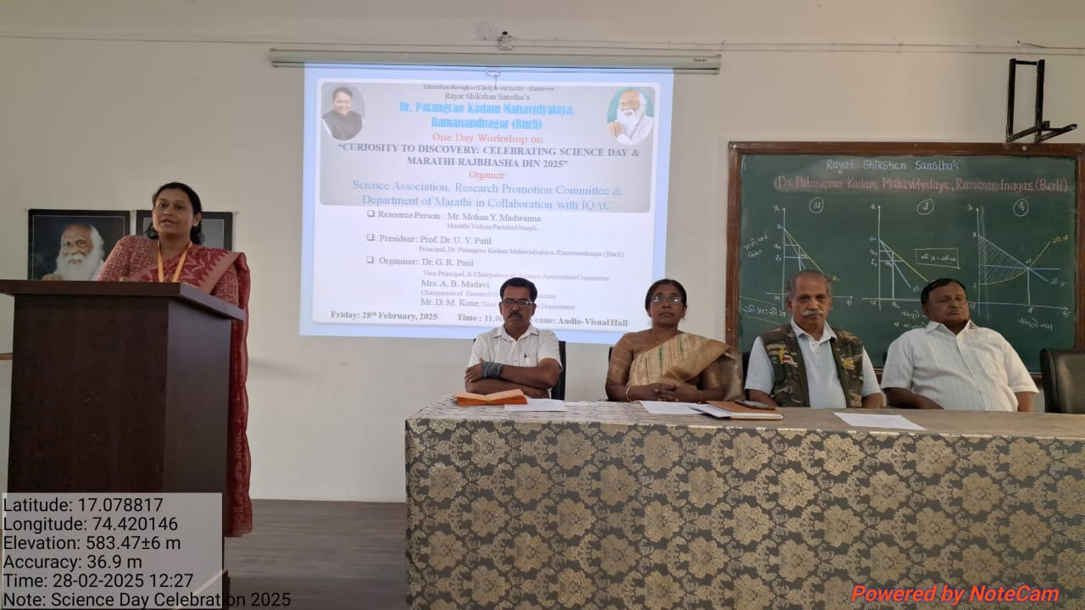
While felicitating chief guest
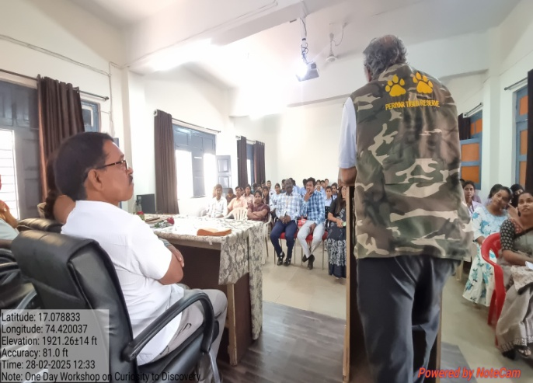 | 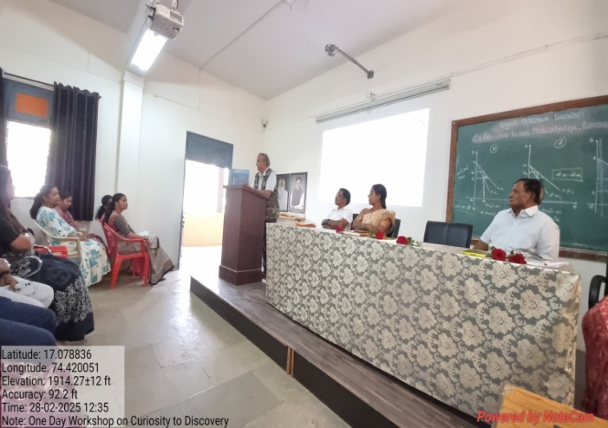
Madvanna Sir while guiding to students

